CSS-Computer Study Stuff

PASS FAIl ANAlYSIS SUBJECT WISE

GRADE SHARE FOR PARTICULAR SUBJECT

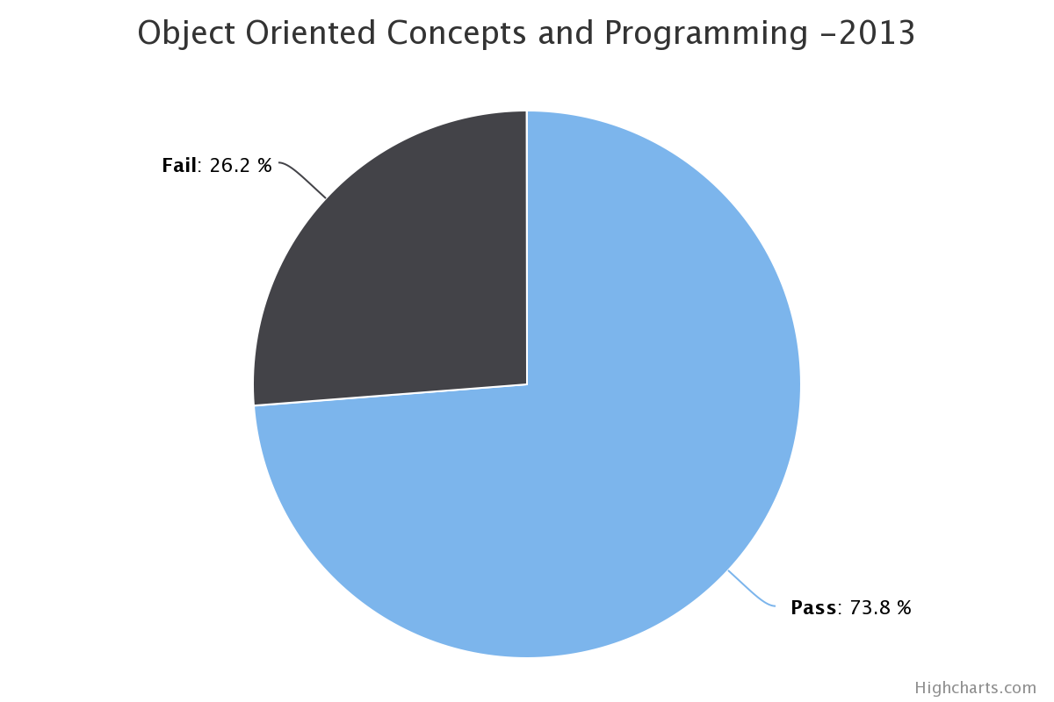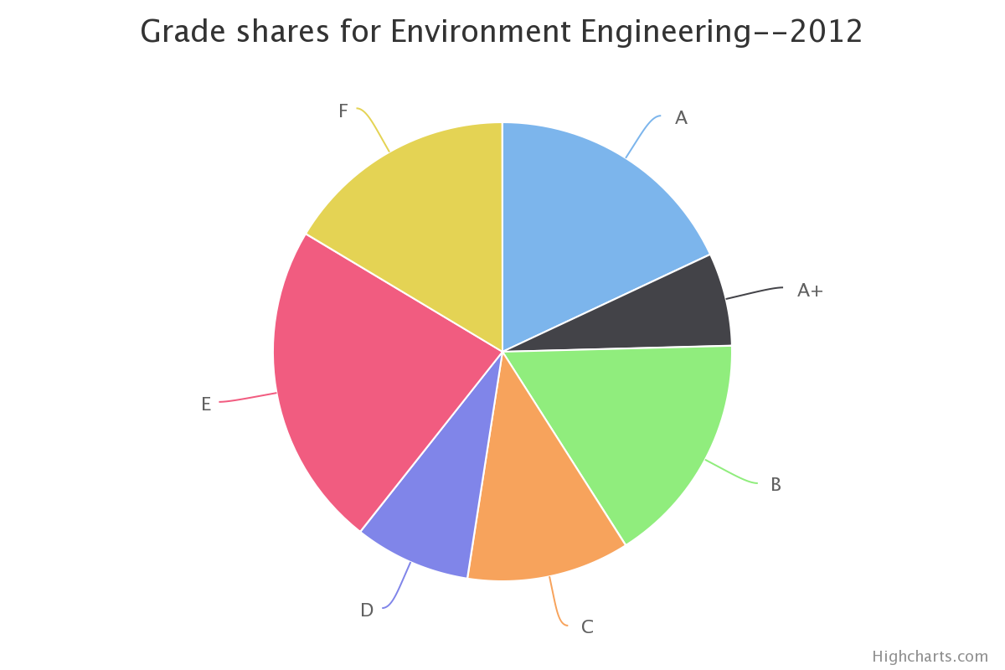

SEMESTER WISE PASS FAIL ANALYSIS

Student Profile

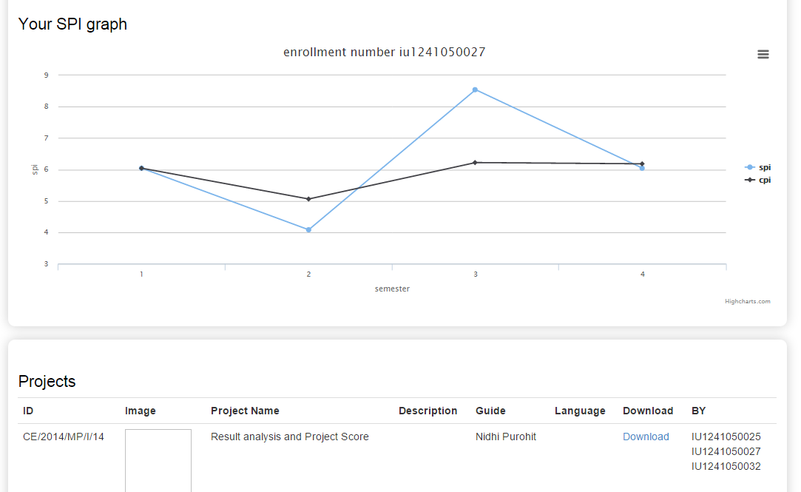

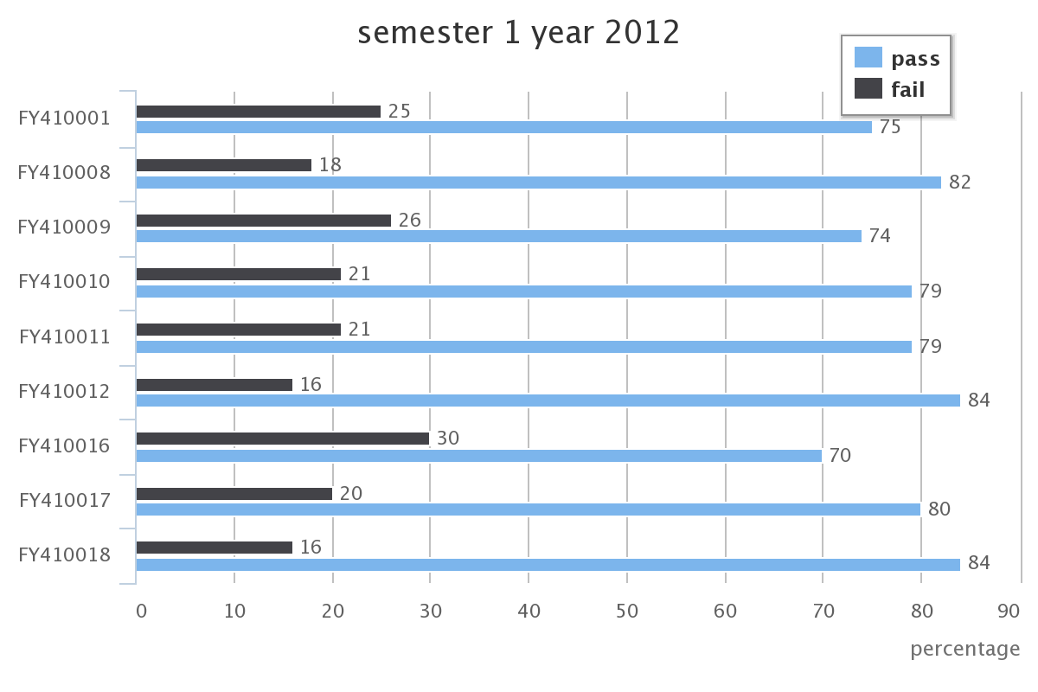

Functions

Project upload/download portal

**view Result**  : Individual result analysis .  
  
**Year wise**  : comparison of yearly Pass percentage for subject .  
  
**semester wise** : comparison of different subject of semester over a year.  
 **grade wise**  : comparison of different grade for subject of semester over a year.  
  
**subject wise**  : pass fail graph of particulate subject.  
  
**Toppers** : University Toppers 